Seventy Miles in Hell

The Darién Gap was once considered impassable. Now hundreds of thousands of migrants are risking treacherous terrain, violence, hunger, and disease to travel through the jungle to the United States.

By [Caitlin Dickerson](https://www.theatlantic.com/author/caitlin-dickerson/)

August 6, 2024

They gathered in the predawn dark. Bleary-eyed children squirmed. Adults lugging babies and backpacks stood at attention as someone working under the command of Colombia’s most powerful drug cartel, the Gulf Clan, shouted instructions into a megaphone, temporarily drowning out the cacophony of the jungle’s birds and insects: Make sure everyone has enough to eat and drink, especially the children. Blue or green fabric tied to trees means keep walking. Red means you’re going the wrong way and should turn around.

Next came prayers for the group’s safety and survival: “Lord, take care of every step that we take.” When the sun peeked above the horizon, they were off.

More than 600 people were in the crowd that plunged into the jungle that morning, beginning a roughly 70-mile journey from northern Colombia into southern Panama. That made it a slow day by local standards. They came from Haiti, Ethiopia, India, the Democratic Republic of the Congo, Brazil, Peru, Ecuador, and Venezuela, headed north across the only strip of land that connects South America to Central America.

The Darién Gap was [thought for centuries to be all but impassable](https://story.californiasunday.com/darien-gap-migration/). Explorers and would-be colonizers who entered tended to die of hunger or thirst, be attacked by animals, drown in fast-rising rivers, or simply get lost and never emerge. Those dangers remain, but in recent years the jungle has become a superhighway for people hoping to reach the United States. [According to the United Nations](https://news.un.org/en/story/2024/05/1149806), more than 800,000 may cross the Darién Gap this year—a more than 50 percent increase over last year’s previously unimaginable number. Children under 5 are the fastest-growing group.

The U.S. has spent years trying to discourage this migration, [pressuring its Latin American neighbors to close off established routes](https://progressive.org/latest/other-americans-us-migrant-border-routes-abbott-181122/) and deny visas to foreigners trying to fly into countries close to the U.S. border. Instead of stopping migrants from coming, this approach has simply rerouted them through the jungle, and shifted the management of their passage onto criminal organizations, which have eagerly taken advantage. The Gulf Clan, which now calls itself Ejército Gaitanista de Colombia, effectively controls this part of northern Colombia. It has [long moved drugs and weapons through the Darién Gap](https://pulitzercenter.org/stories/colombia-beware-gap); now it moves people too.

Everyone who works in the Darién Gap must be approved by the cartel and hand over a portion of their earnings. They have built stairs into hillsides and outfitted cliffs with ladders and camps with Wi‑Fi. They advertise it all on TikTok and YouTube, and anyone can book a journey online. There are many paths through. The most grueling route is the cheapest—right now, about $300 a person to cross the jungle on foot. Taking a boat up the coast can cost more than $1,000.

I went to the Darién Gap in December with the photographer Lynsey Addario because I wanted to see for myself what people were willing to risk to get to the United States. Before making the journey, I spoke with a handful of journalists who had done so before. They had dealt with typhoid, rashes, emergency evacuations, and mysterious illnesses that lingered for months. One was tied up in the forest and robbed at gunpoint. They said that we could take measures to make the journey safer but that ultimately, survival required luck.

Each year, Panamanian authorities [remove dozens of bodies from the jungle](https://www.hrw.org/report/2023/11/09/hell-was-my-only-option/abuses-against-migrants-and-asylum-seekers-pushed-cross). Far more are swallowed up by nature. These deaths are the result not only of extreme conditions, but also of [the flawed logic embraced by the U.S.](https://www.theatlantic.com/ideas/archive/2024/08/border-kamala-harris-migration/679336/) and other wealthy nations: that by making migration harder, we can limit the number of people who attempt it. This hasn’t happened—not in the Mediterranean, or the Rio Grande, or the Darién Gap. Instead, more people come every year. What I saw in the jungle confirmed the pattern that has played out elsewhere: The harder migration is, the more cartels and other dangerous groups will profit, and the more migrants will die.

The night before we set out, a Venezuelan father named Bergkan Rhuly Ale Vidal paced around a camp at the jungle’s mouth, packing and repacking his family’s bags. He and his partner, Orlimar, had their children with them: 2-year-old Isaac and 8-year-old Camila. Even in the dark the air was sweltering, and Bergkan’s mind was spinning with worry. What if one of the children fell and hurt themselves, or came down with a fever? What if one was bitten by a snake? In trying to salvage his family’s future, had he gravely miscalculated?

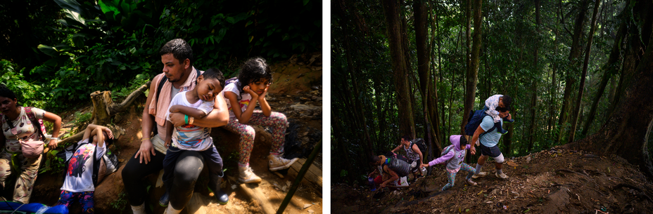Bergkan Rhuly Ale Vidal and his partner, Orlimar, set out to traverse the Darién Gap with their children, Isaac, 2, and Camila, 8. They traveled with Orlimar’s cousin Elimar and her two children. (Lynsey Addario for *The Atlantic*with support from National Geographic Society)

The first day, the path was studded with boulders and trip-wired with vines. It weaved across a river so many times that I quickly gave up on dumping out my rubber boots, because they would only fill again minutes later. Bergkan’s family’s tennis shoes were already ripped and disintegrating. The hills were slick with mud and so steep that we were often not so much walking as climbing on our hands and knees, holding on to mangled roots.

We passed stands selling bottles of water and Gatorade, two for $5. Porters, known as *mochileros*, circled the family, hawking their services. “We carry backpacks, we carry children!” they chanted. They charge roughly $100 a day, and also barter with migrants for items in their backpacks. Orlimar tried trading a pair of old headphones for new boots, but was rejected. A couple of times, she and Bergkan lost patience with the porters and yelled, “We have no money!”

Midmorning, we reached the route’s toughest hill. After half an hour of climbing, Bergkan crashed to the ground, his chest heaving. Orlimar threw down her belongings. “What do you have in that bag?” he asked her.

“Shoes—sandals,” Orlimar said in a voice so soft, she was barely audible.

Bergkan told her to dump any weight she could. She began pulling out clean clothes. “Someone else will be able to use them,” he said. But the other families nearby were also unloading supplies. The people who had the strength to keep hiking charged past us, staring straight ahead, as if exhaustion were an illness that they might catch just by looking at it.

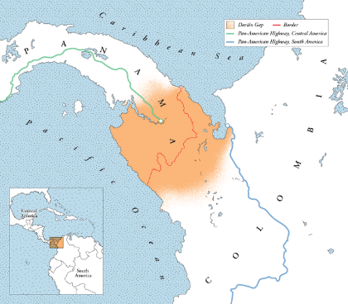

Crossing the jungle can take three days or 10, depending on the weather, the weight of your bags, and pure chance. A minor injury can be catastrophic for even the fittest people. Smugglers often downplay how many days the journey will take—Bergkan had been told to plan for two. A few hours into the trip, he began to realize that they were nowhere near as deep into the jungle as they needed to be, which meant they might not have enough food to get them out.

Bergkan and Orlimar had planned for a different life. They’d met as teenagers and gone to college together, Orlimar studying nursing and Bergkan engineering. But Venezuela’s economy imploded in 2014, the result of corruption and mismanagement. Then an authoritarian crackdown by the leftist president, Nicolás Maduro, led to punishing American sanctions. The future they had been working toward ceased to exist. In the past decade, [at least 7.7 million Venezuelans have fled](https://reporting.unhcr.org/operational/situations/venezuela-situation).

Bergkan and Orlimar spent five years taking any job they could get, first in Venezuela and then in Peru, while they watched their friends and classmates leave, one after another, for the United States. Then Orlimar’s cousin Elimar, who was like a sister to her, came to them with an offer: Her boyfriend, who was living in Dallas, would pay for Bergkan’s family to take the cheapest route across the jungle, if Elimar and her two children—who were 6 and 8—could go with them. “No one in Venezuela can lend you money, much less that amount,” Bergkan told me. “It was our moment.” They planned to stay in the U.S. only until Venezuela’s economy recovered and they could return home.

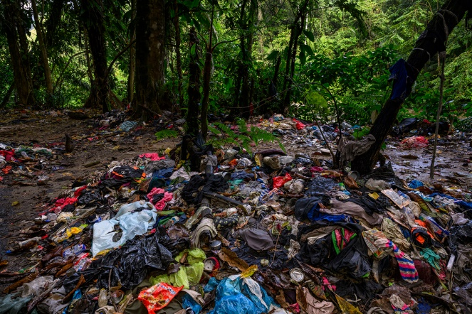Migrants discarded clothing and gear to lighten their packs. (Lynsey Addario for *The Atlantic*with support from National Geographic Society)

We trudged uphill for hours. Isaac teetered on Bergkan’s shoulders. Gripping his son’s feet, Bergkan adopted a strategy of sprinting up a stretch of hill for about 30 seconds, then collapsing again. His limbs shook and his face turned an ominous shade of purple. “The weight you carry is in your mind,” he said at one point, giving himself a pep talk. Camila stopped cold a couple of times, holding up the long line of people behind her, and yelled, “Mommy, I can’t!”

Around 1 p.m., Isaac fell asleep, his limp body rocking back and forth. “It feels like his weight has tripled,” Bergkan told Orlimar. They sat down on a hillside to regroup. Elimar tried coaxing her nephew awake with lollipops, but he was unresponsive. Other parents stopped to ask if he was okay. Bergkan pulled a packet of electrolyte powder out of his bag. He mixed it with water, then shook Isaac awake and told all four children to down it. “We’re going to get you out of here,” Bergkan said, more to himself than to anyone else.

Guides and porters follow the migrants with their iPhones rolling, asking, “Have we treated you well?” They post the videos on social media, selling trips across the jungle as if they were joyful nature walks.

Eventually, a porter explained that we were moving too slowly to make it to Panama that day; we would have to sleep at a camp for stragglers. When we arrived, we saw wooden platforms for tents, bucket showers and toilets, and a couple of outdoor kitchens with Colombians serving plates of chicken and rice—all for a price. People around us began purchasing Wi‑Fi for $2 an hour so they could ask relatives to send them more money; transfers carried a 20 percent fee. Elimar began circulating through the camp, asking other Venezuelans for a loan to help her contact her boyfriend. Bergkan, Orlimar, and their children sat down and rubbed their aching limbs. They had no one to call.

In the three trips I took to the Darién Gap over the course of five months, I saw new bridges and paved roads appear deeper in the jungle, Wi‑Fi hotspots extend their reach, and landmarks that were previously known only by word of mouth appear on Google Maps. Looking down at a thrashing river, I held on to ropes that made it safer—slightly—to creep across sheer rock faces behind parents with crying babies strapped to their chests.

Guides and porters follow the migrants in the jungle with their iPhones rolling, asking, “Do you feel good?” and “Have we treated you well?” They film incessantly during the first day of walking, when people are still able to conjure a smile. (Even I ended up in one of their videos.) They post the videos on social media, selling trips across the jungle as if they were joyful nature walks. The profit motives of the cartel have become yet another factor fueling migration.

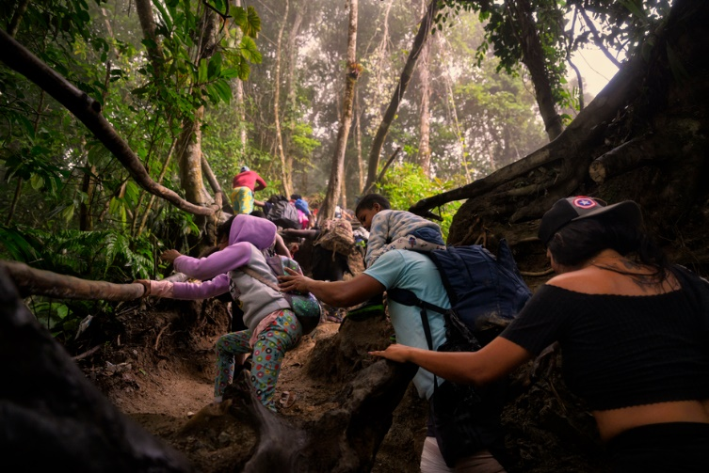Bergkan and his children ascend a mountainous stretch of trail near the Colombian border with Panama. (Lynsey Addario for *The Atlantic*with support from National Geographic Society)

The UN has tried to counteract these messages by stationing migration officials at bus stations and other checkpoints along the way to the Darién Gap; they warn people of the dangers ahead and try to persuade them to reconsider. Those efforts have been largely ineffective. “People come with tunnel vision, like, ‘I must get to the United States,’ ” Cristian Camilo Moreno García, a UN migration official based in northern Colombia, told me. “Turning back is not an option.”

On the second morning of our journey, about 150 people filed out of the camp and waited for the sun to rise before they started walking. Bergkan and his family ate nothing; they needed to conserve the few cans of tuna and packages of cookies they had left. The children were still in their pajamas, some of their only remaining clean clothes. Two women stood at the end of the line collecting final payments and then handing each person a wristband, the kind you might get at a music festival, to show that they had paid. “Please take out your money so that we can move you along faster!” one yelled.

We walked along a narrow ridge with steep cliffs dropping off on either side, all of us trudging much slower than the day before. After about an hour and a half, Elimar’s son, Luciano, crumpled to the ground. The adults gathered around him. “Take off his sweater—he’s suffocating!” one yelled. Without a word, one of the porters Lynsey and I had hired hoisted the child onto his shoulders, apparently unable to watch Luciano struggle any longer. He dashed up the slope and out of sight. Elimar looked defeated but also relieved to have one fewer child to worry about, at least until we made it to the next stopping point.

Word spread down the line that we were approaching the border with Panama. The porters, who had boisterously peddled their services for two days, started to go quiet. Profiting from migration is illegal in Panama, and can carry a sentence of more than 12 years in prison. Panama’s border patrol, known as SENAFRONT, has been enforcing those laws aggressively against people who sell migrants bottles of water, carry their backpacks, or serve as guides. The porter who had picked up Luciano revealed the scar on his chest from a bullet wound that he said he’d sustained on a previous trek, when officers had sprayed bullets into Colombia. He said that we should be prepared to run. (When I asked Jorge Gobea, the head of the agency, if his officers ever shot across the border at Colombian guides, he told me, “If someone armed fights Panama authorities, we use force.”)

The border was marked by a Panamanian flag and piles of trash. Some people posed for pictures and celebrated half-heartedly, unsure if they were nearing the end of the journey or still at the beginning. Orlimar made the sign of the cross, then sat down with her head between her knees. Elimar was the first to notice the Panamanian border guards approaching and warned us: “Get down! Get down!”

Lynsey and I wished the family well and, along with the Colombian porters, sprinted back down the mountain.